**PRACTICAL: 7**

**IMPLEMENT OPENNEBULA**

Client configuration software needed (Download Opennebula sandbox software from open nebula.org)

1.Start vSphere Client.

Enter Static IP address >> Enter Username and Password >> Click Login.

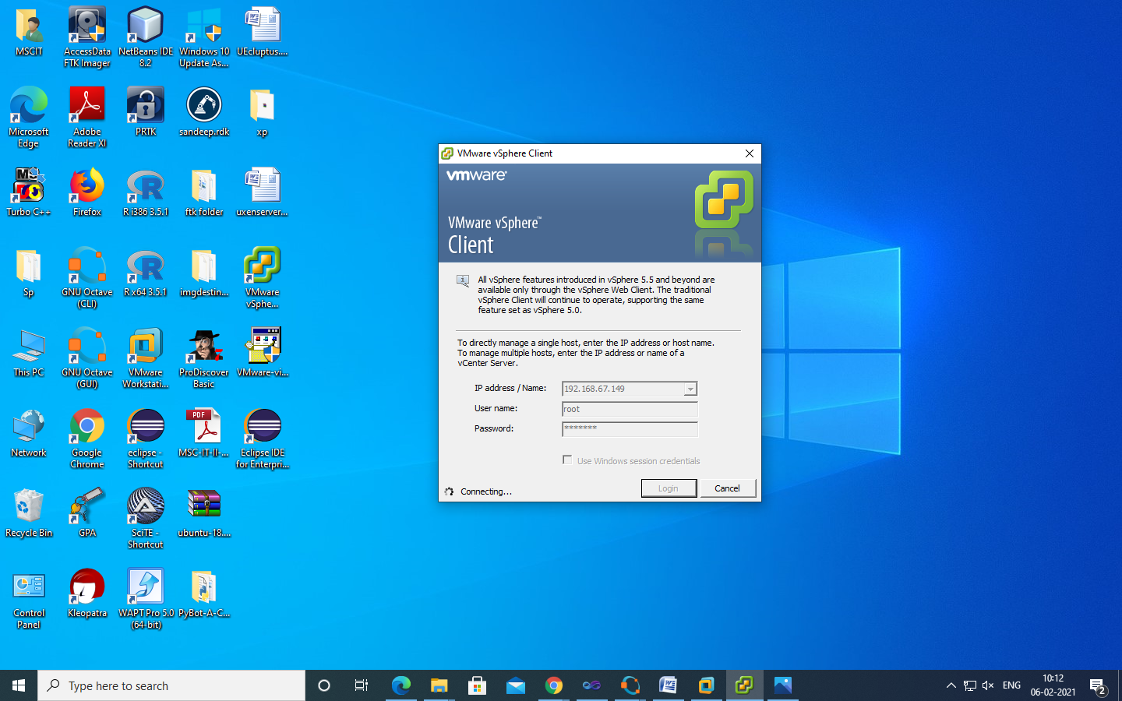

Click on ignore

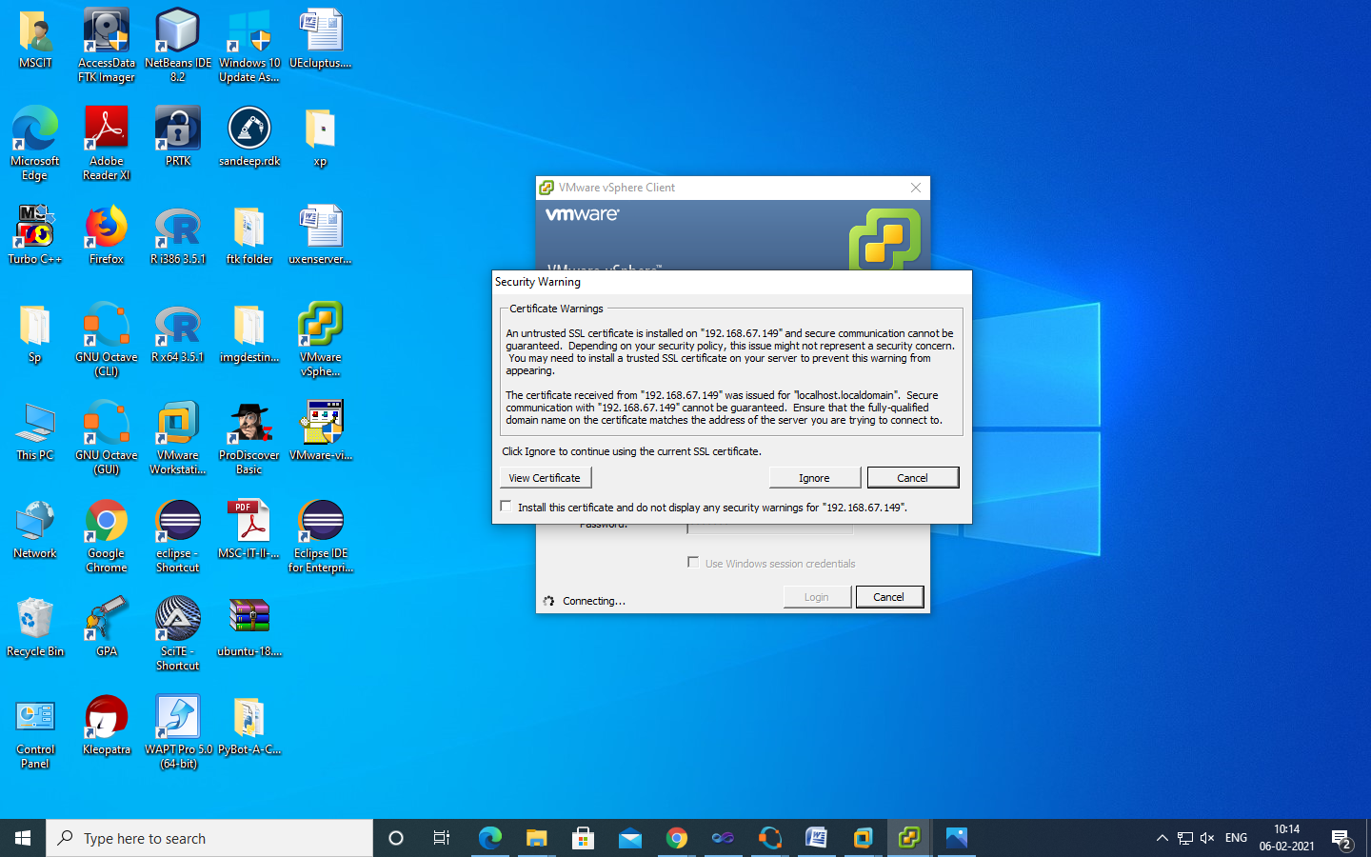

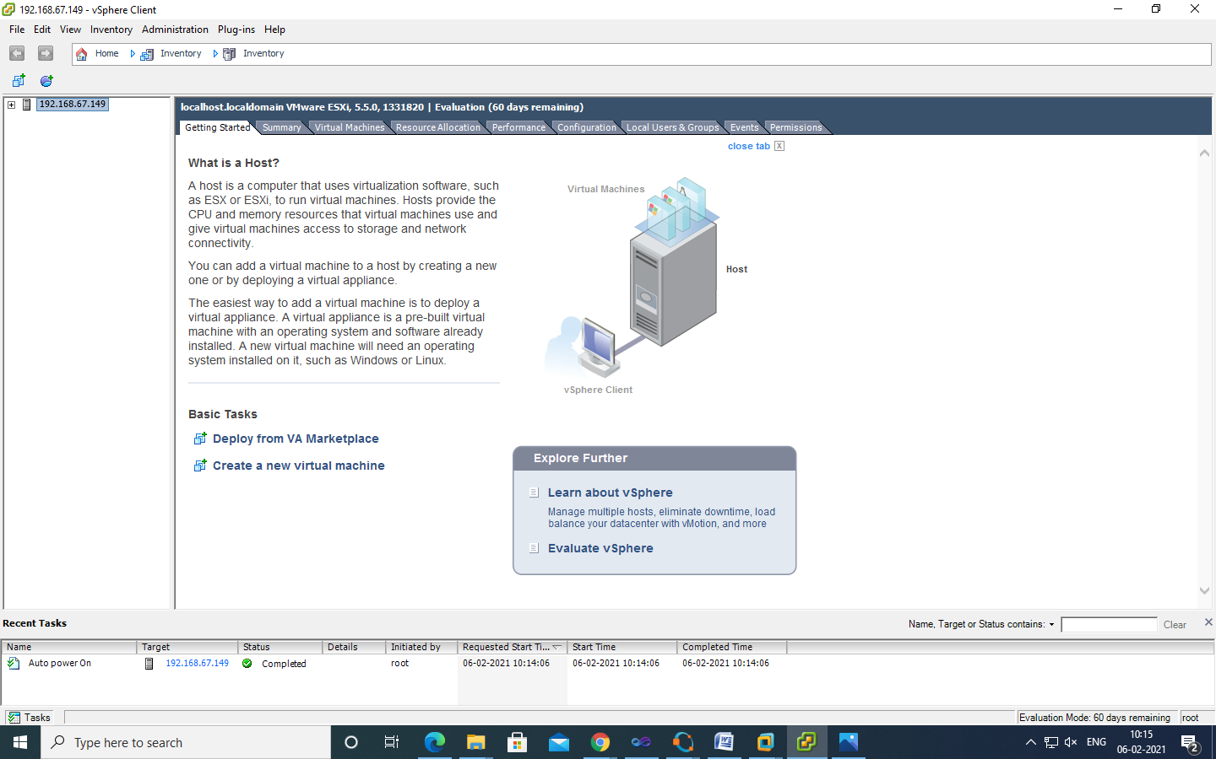

Go to Configuration tab select storage and right click on data store1 and select Browse Datastore.

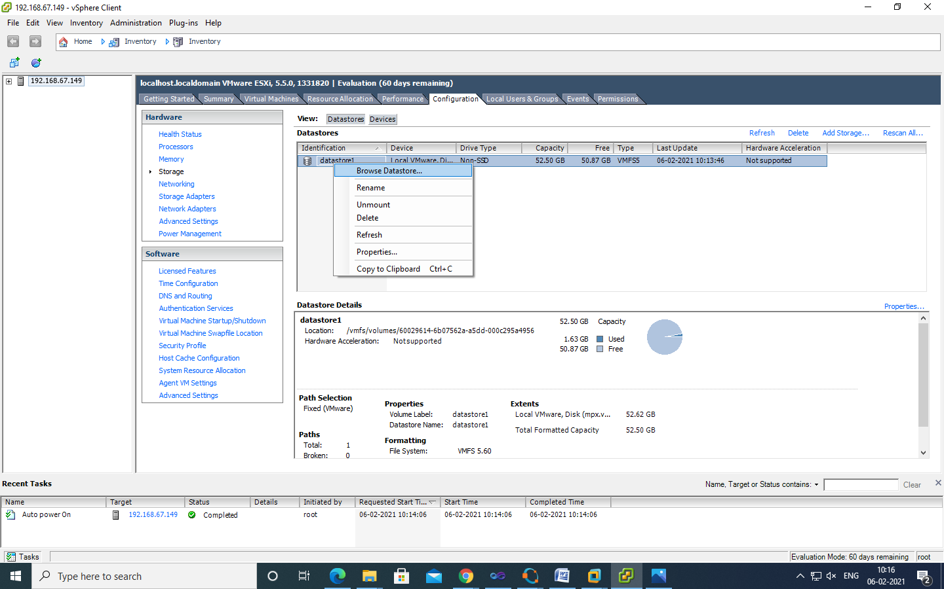

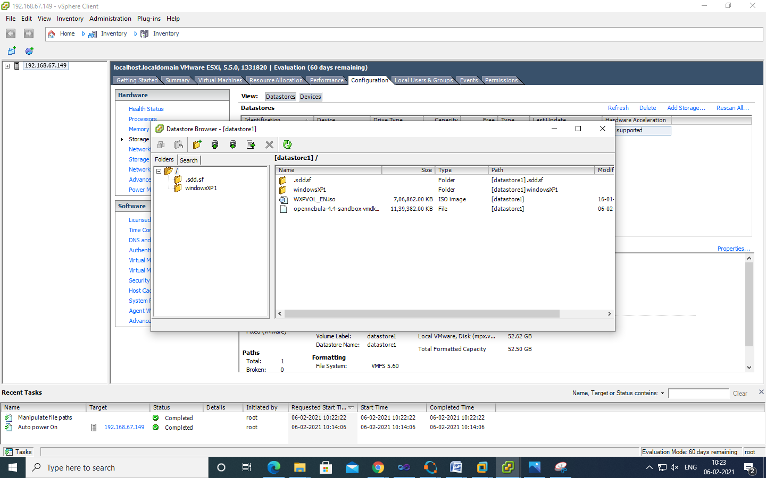

Go in this particular folder opennebula-4.4-sandbox-vmdk and select **disk-flat** file.

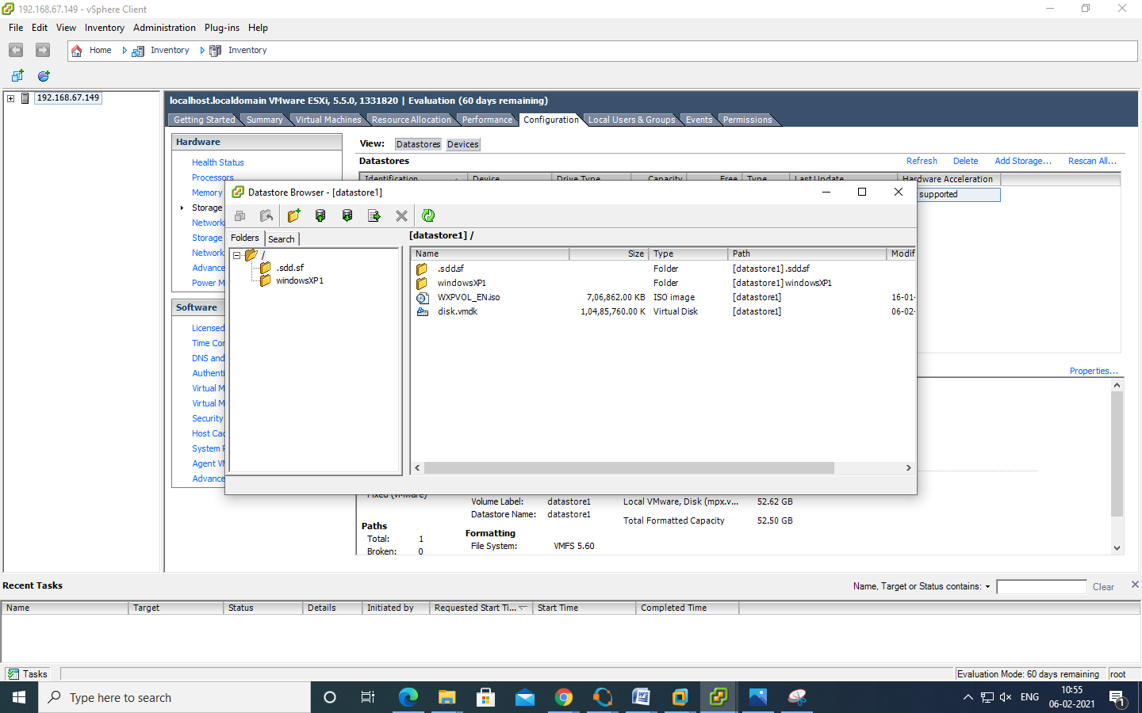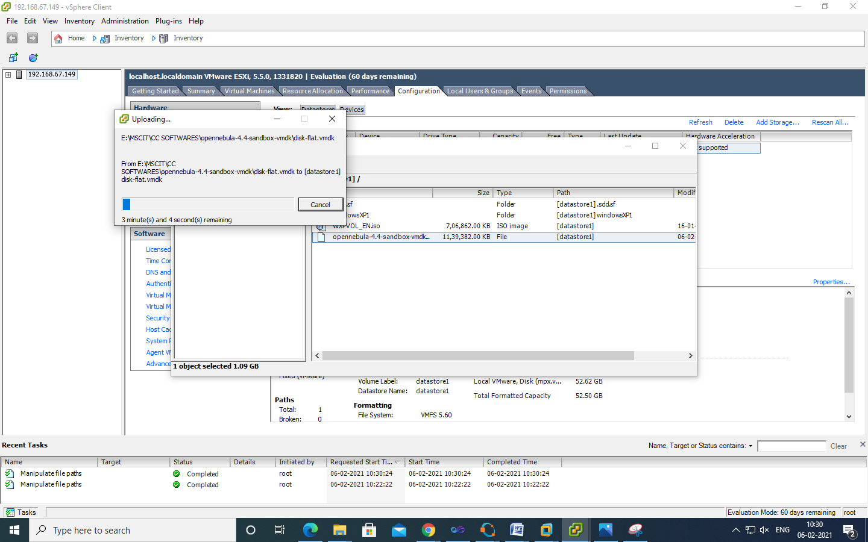

Create a new virtual machine.

Click on file >> Click on the (new virtual machine) icon

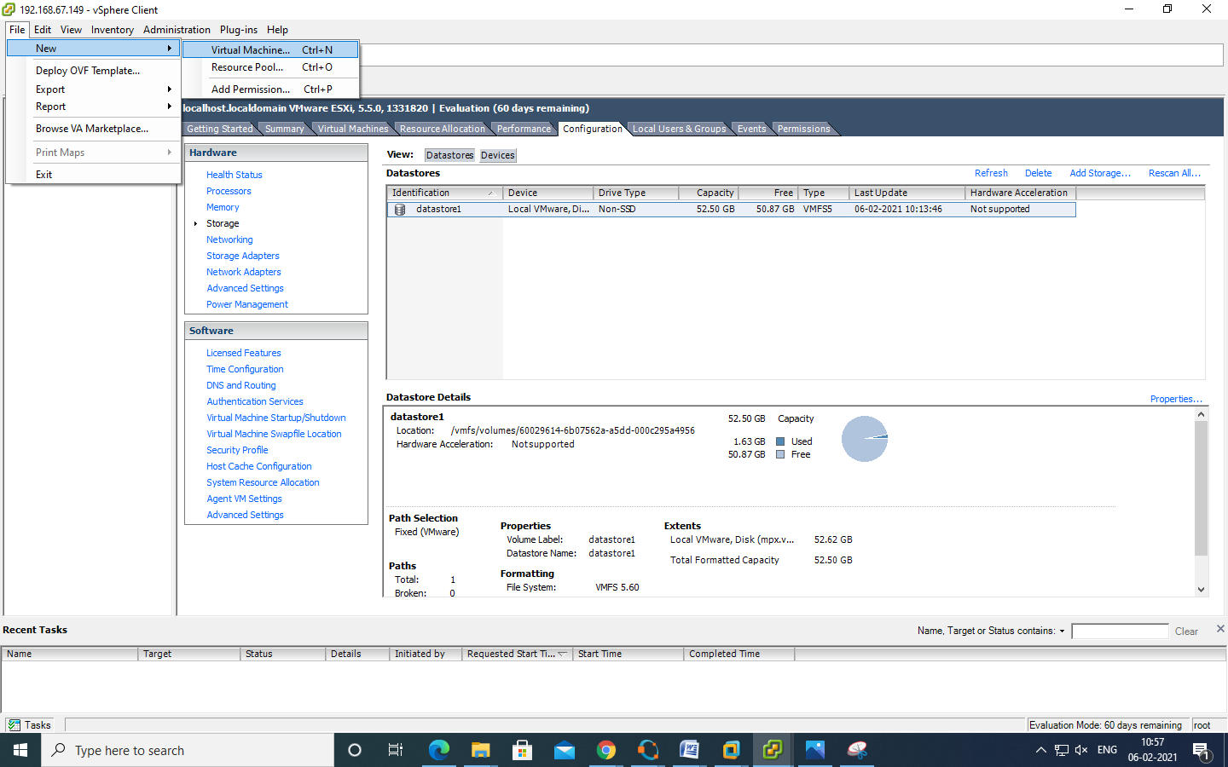

Select custom virtual machine and click on next.

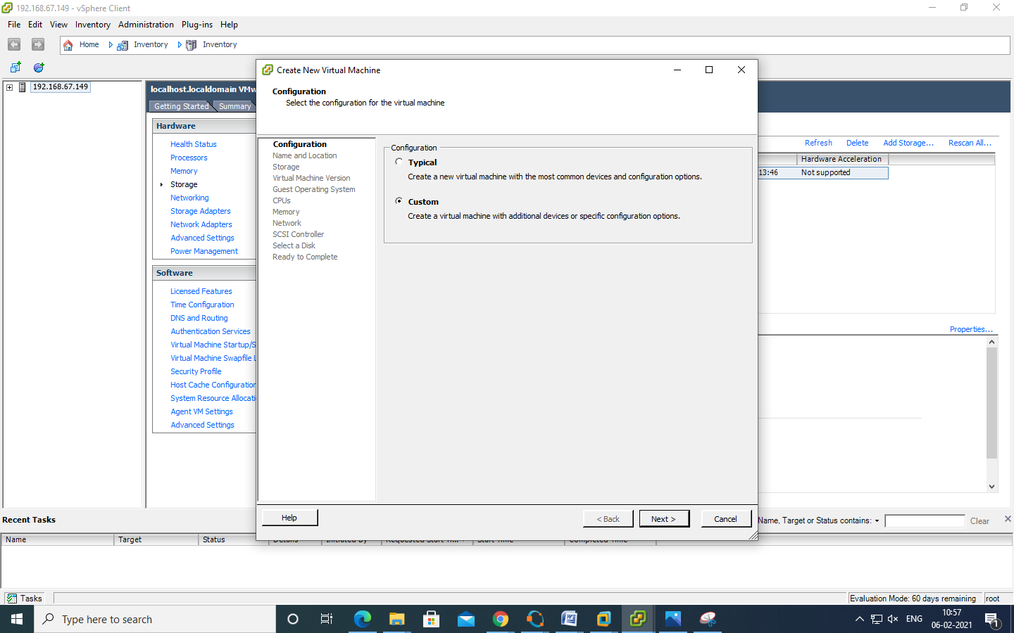

Name : Opennebula-sandbox and click on next.

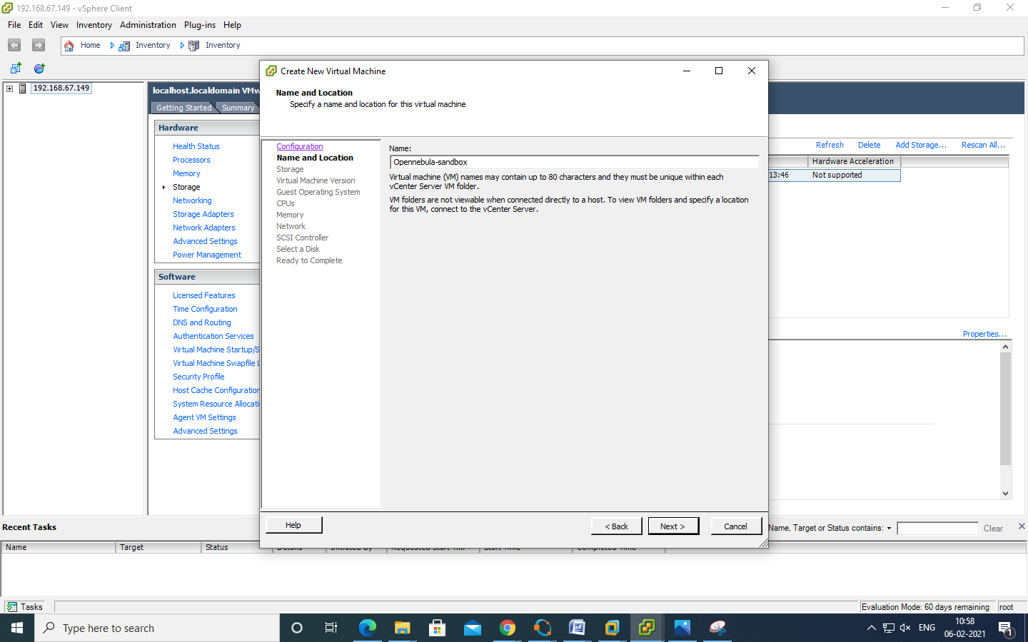

Select the same data store as in the screen and click on next.

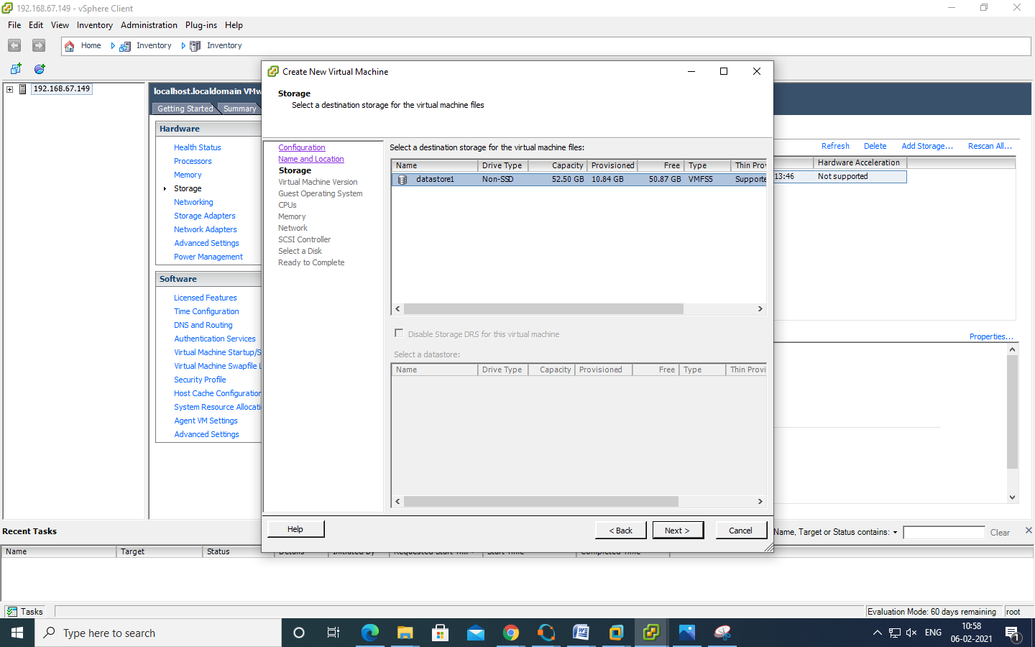

Select virtual machine version 8 and click on next.

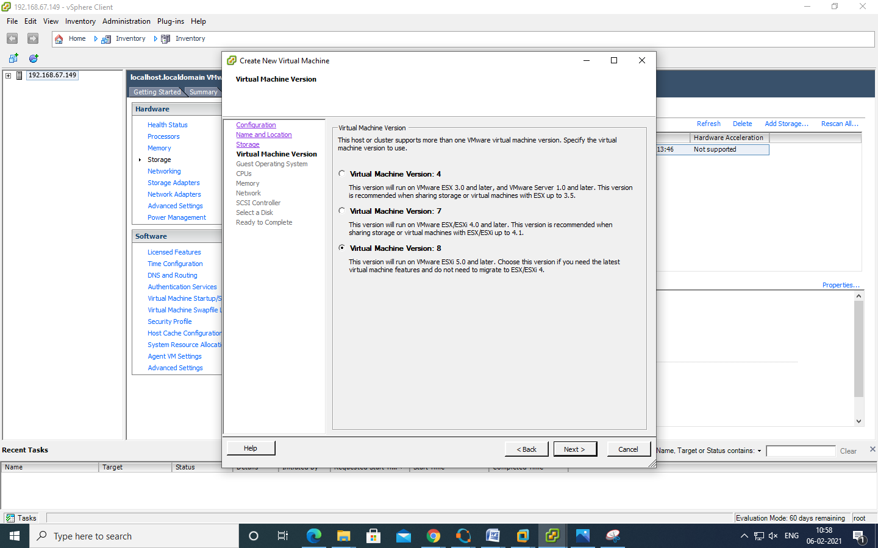

Select linux option-->and then select CentOS 4/5/6(64-bit) and click on next.

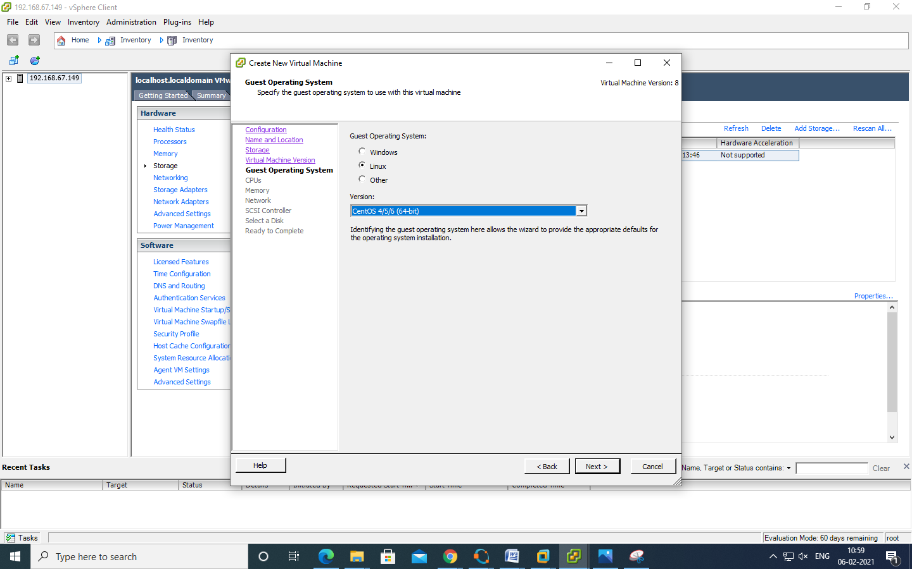

CPUs: Accept the defaults and click next.

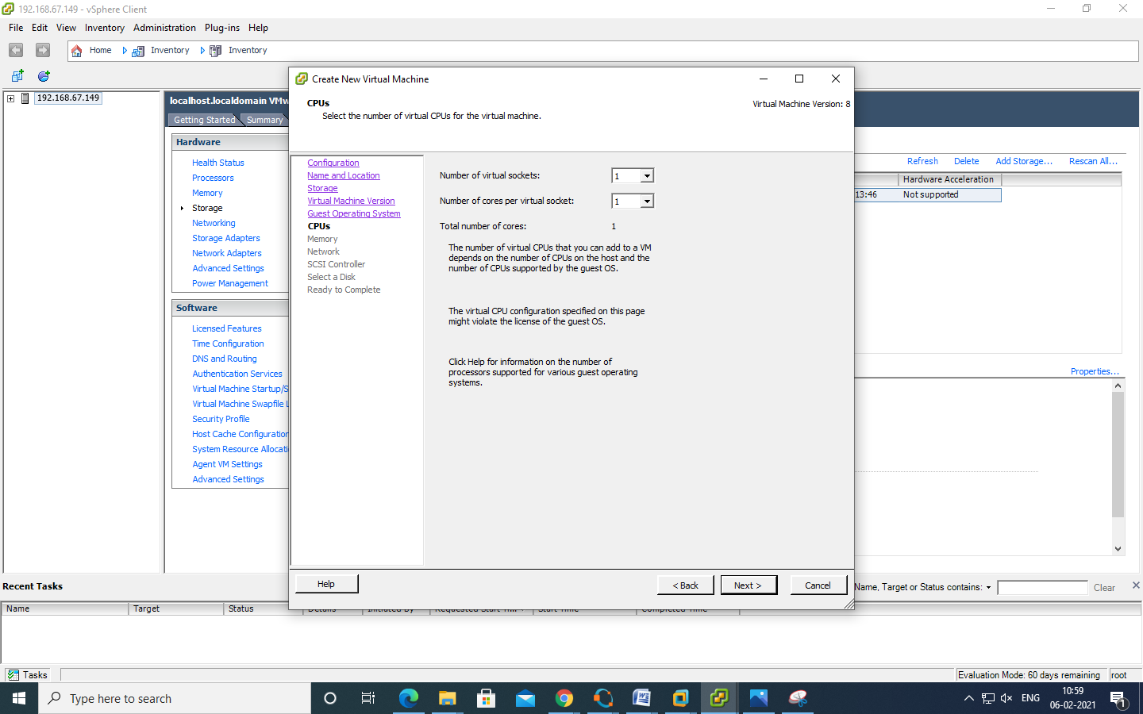

Select memory as 1 GB and click next

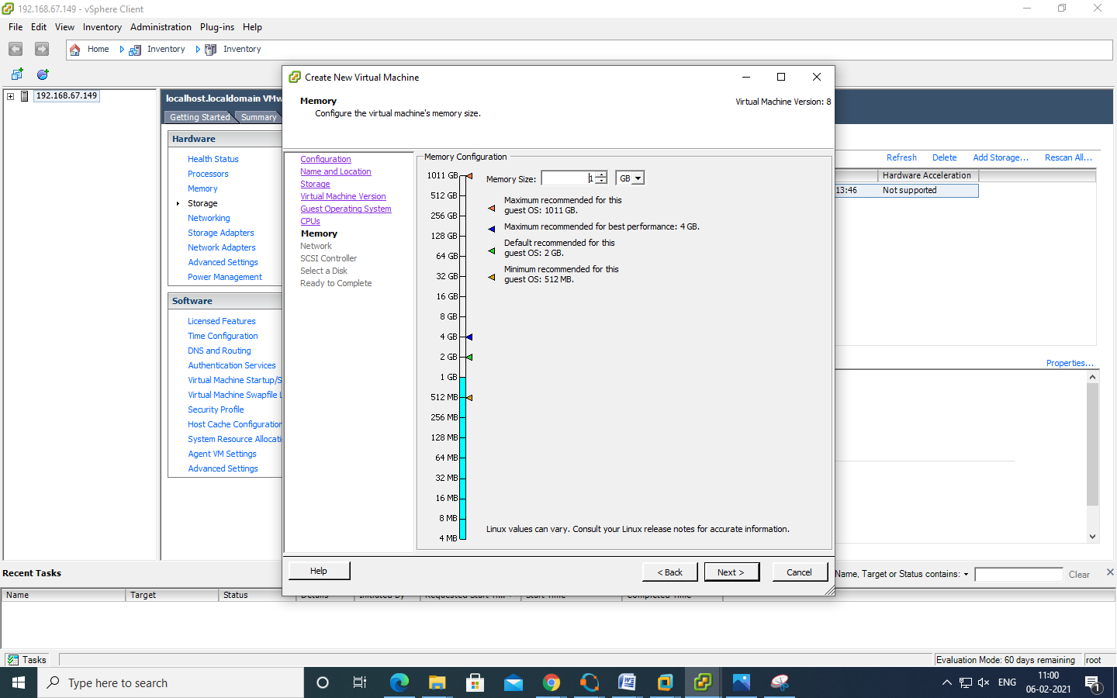

Select it as default and click next

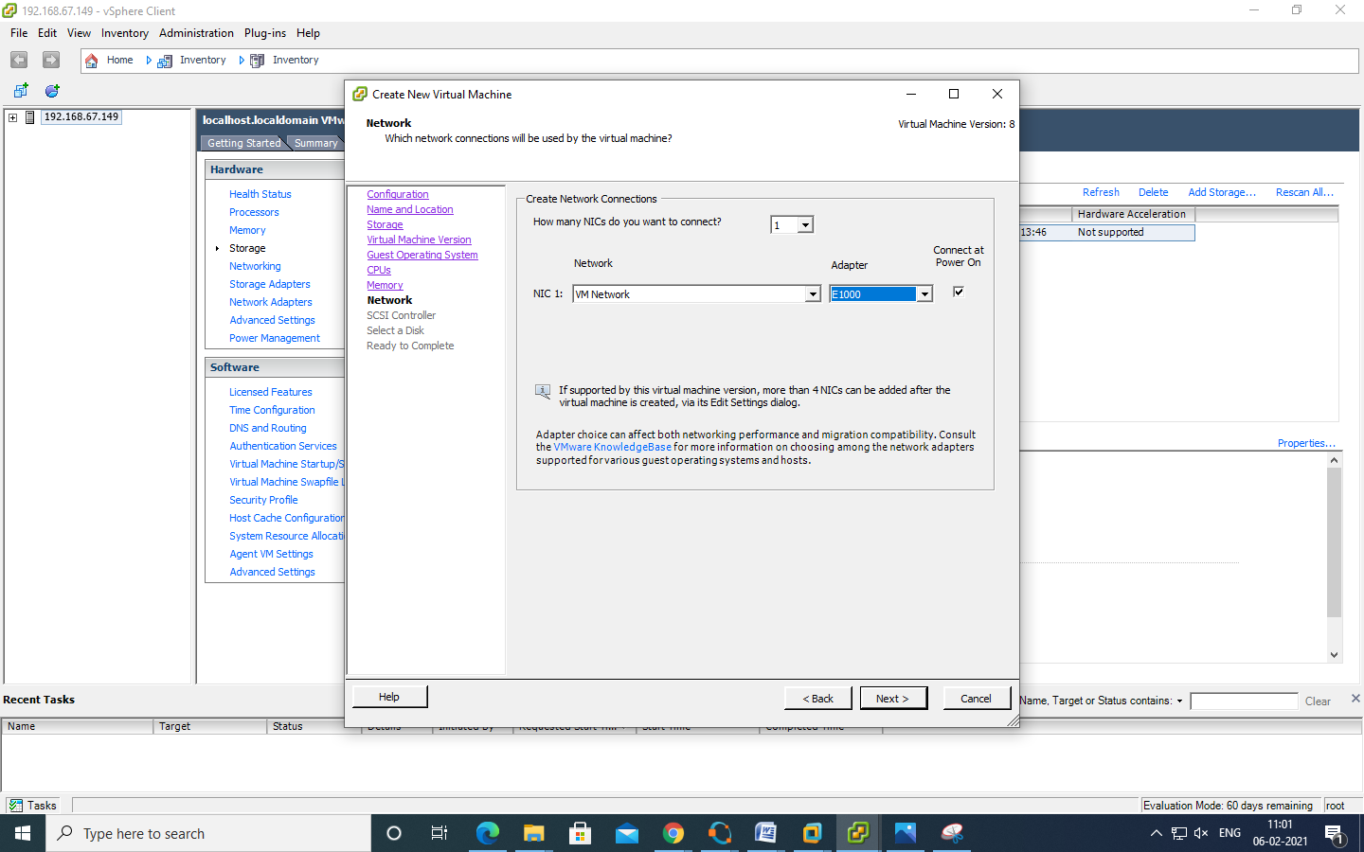

In the SCSI controller select as VMware Paravirtual and click next.

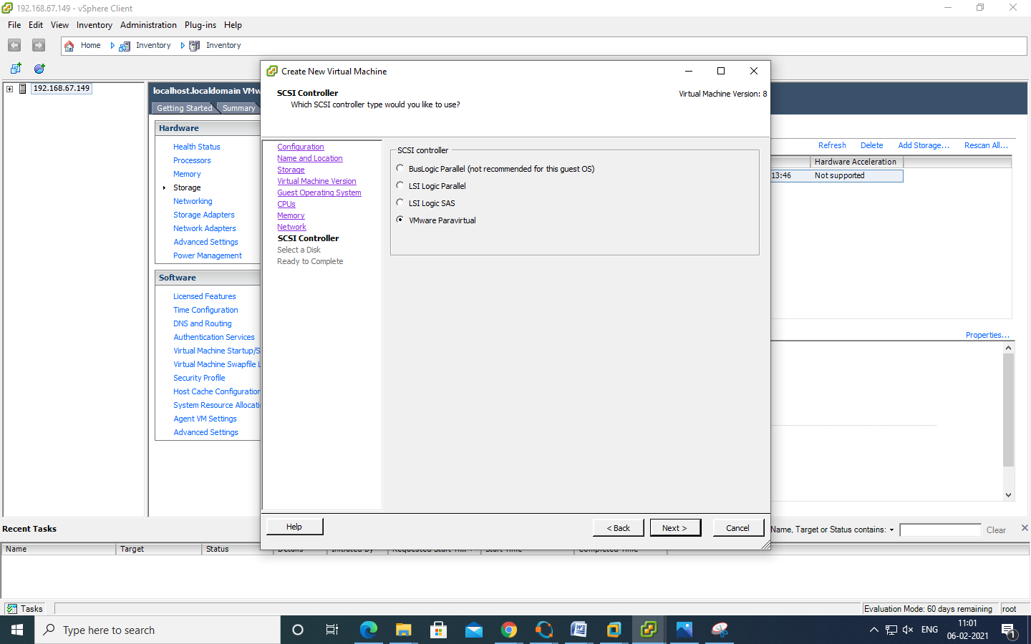

Select disk --> use an existing virtual disk and click next.

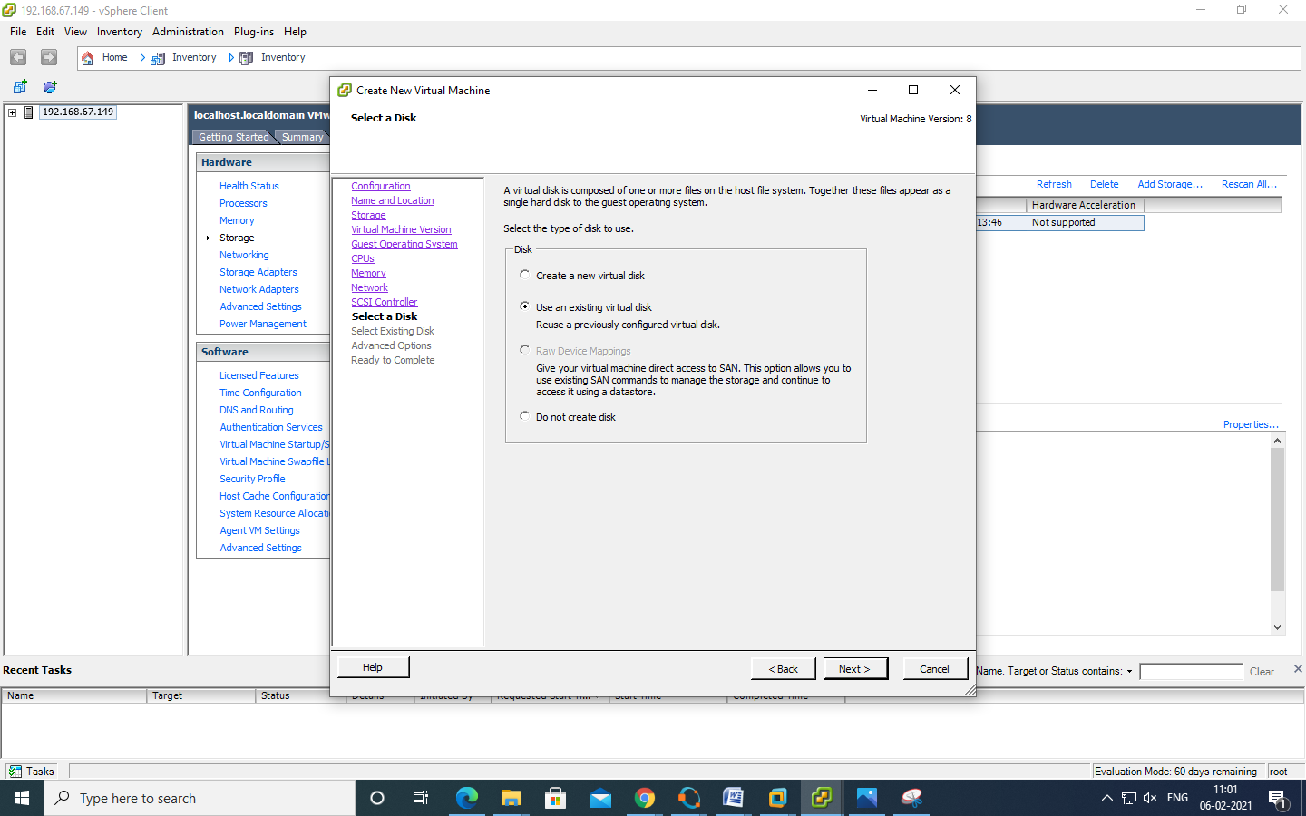  
Click on browse and select data store1

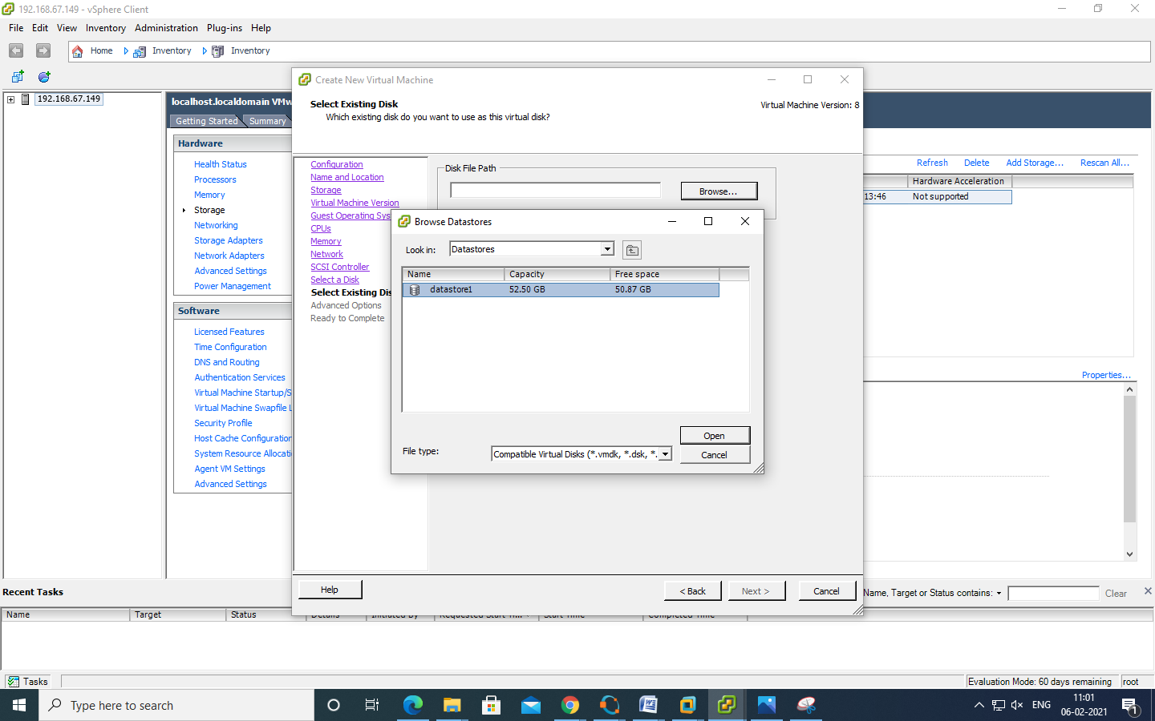

Double click on datastore1 --

You will get disk.vmdk file & click on OK

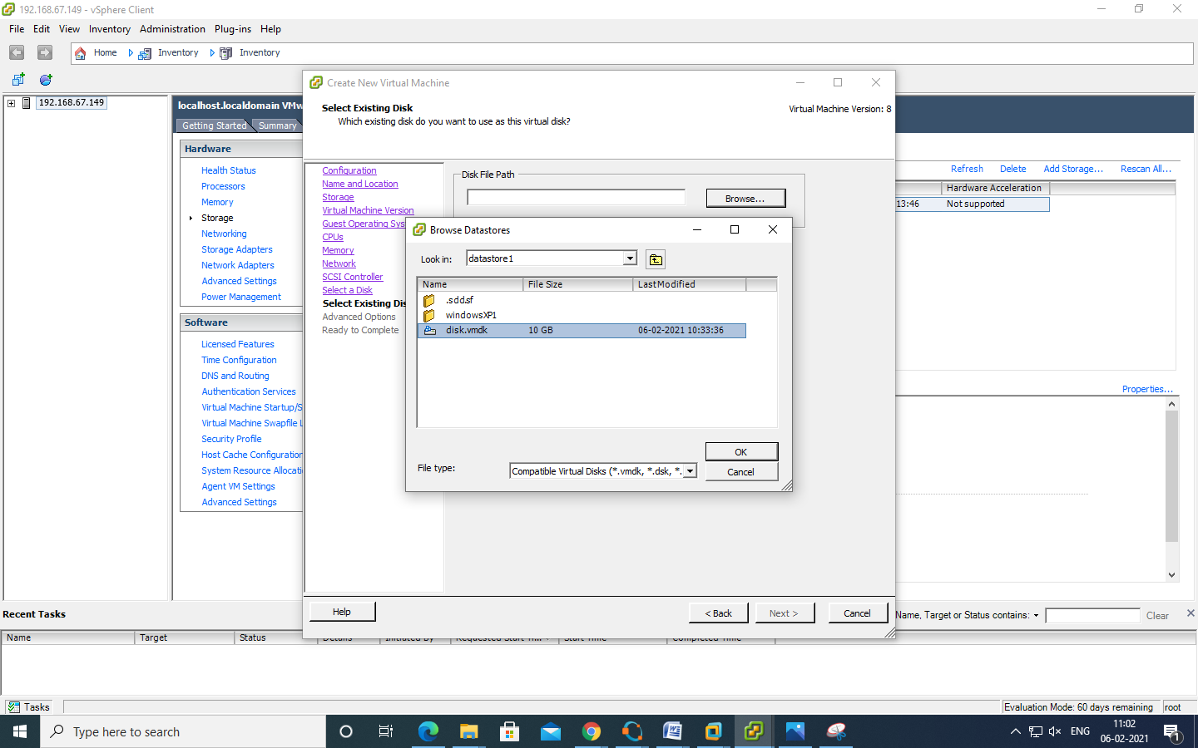

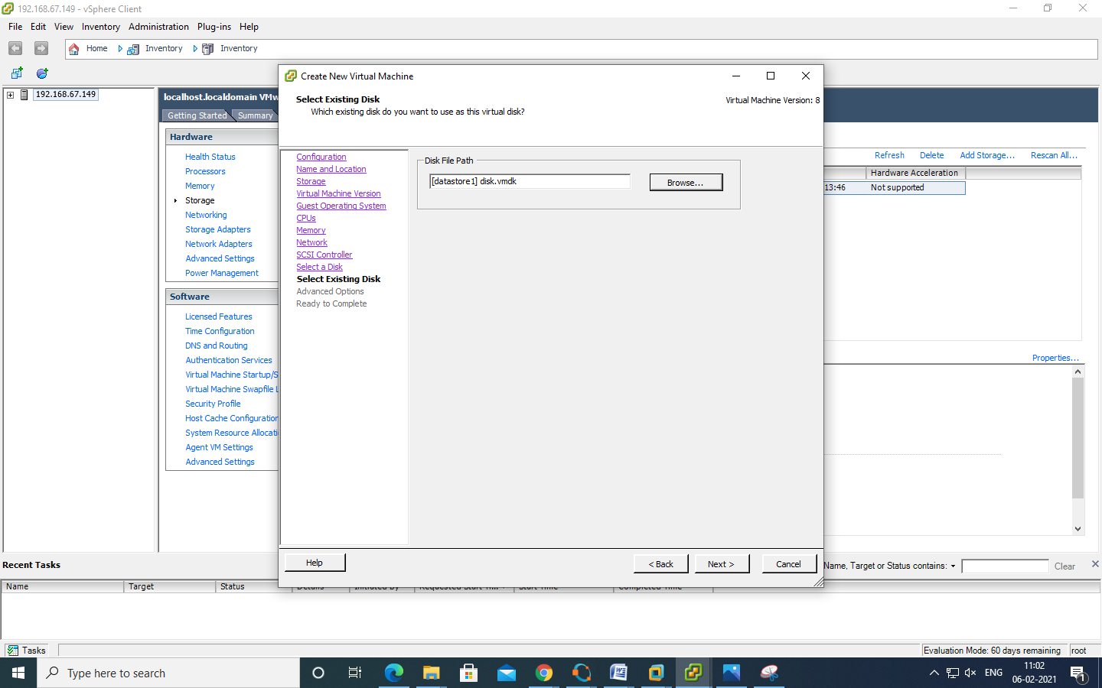

Click on next

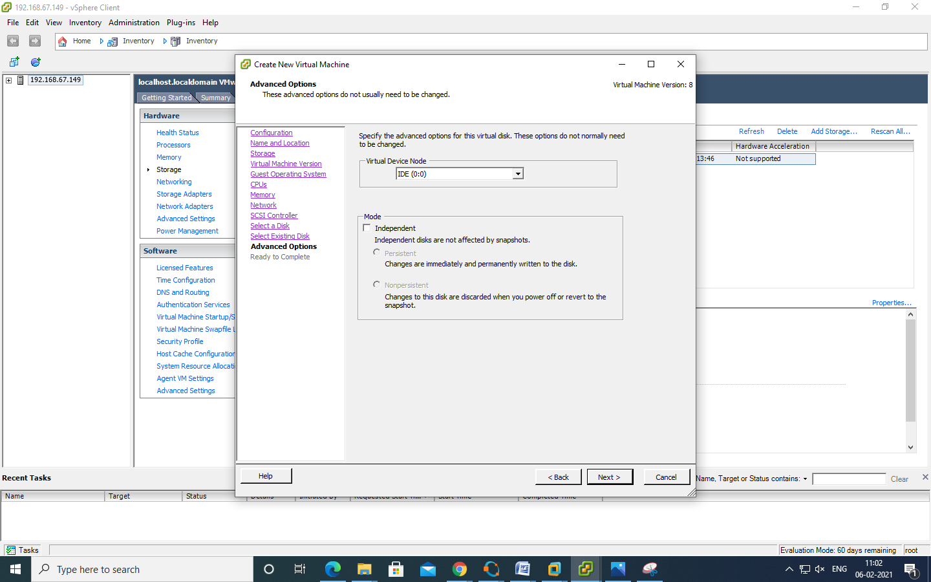  
Click on finish

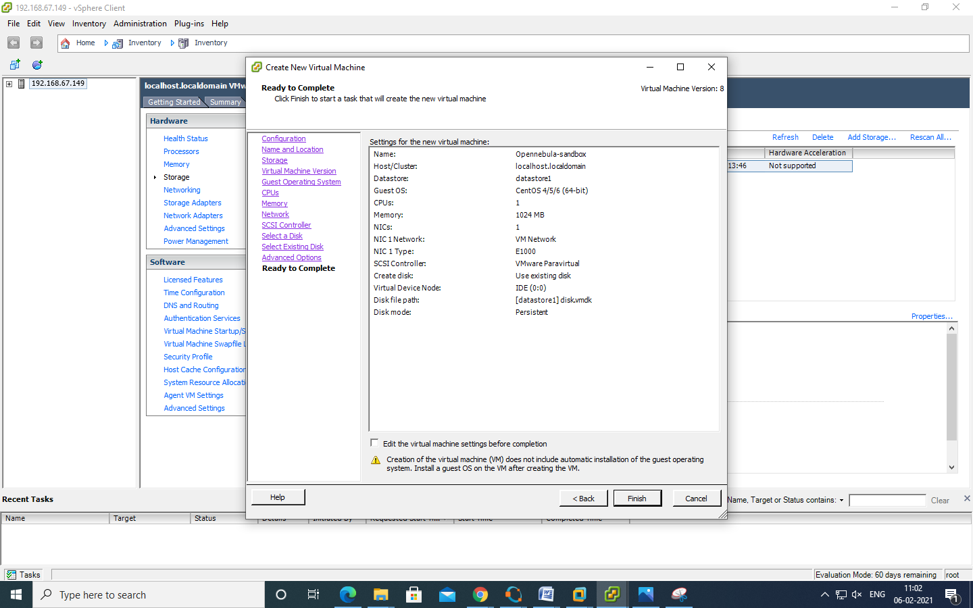

Power on the virtual machine

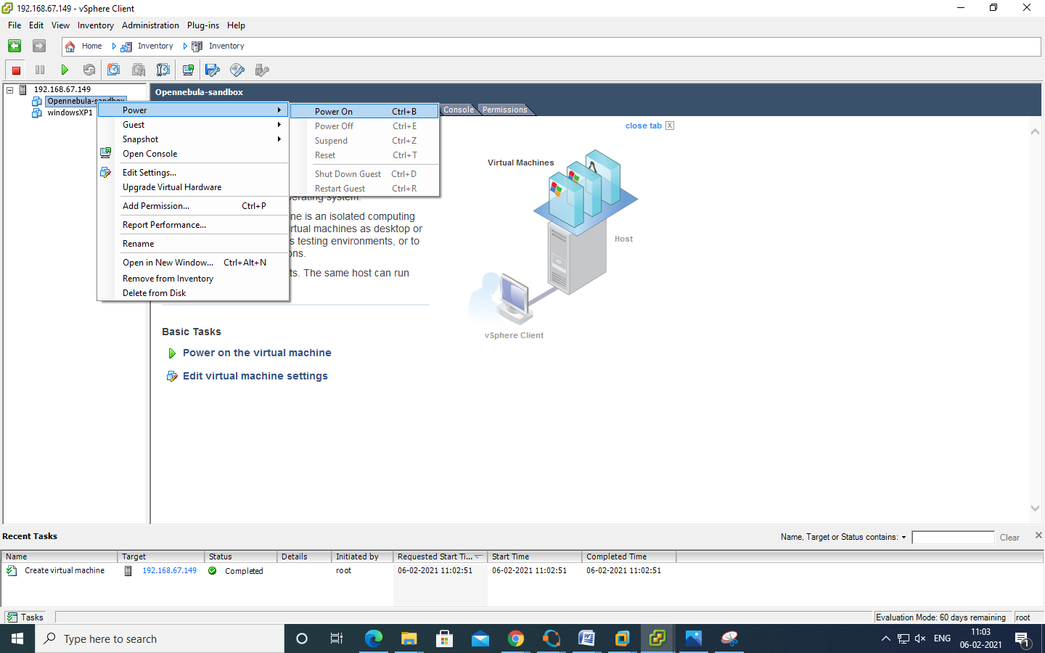

Click on console tab

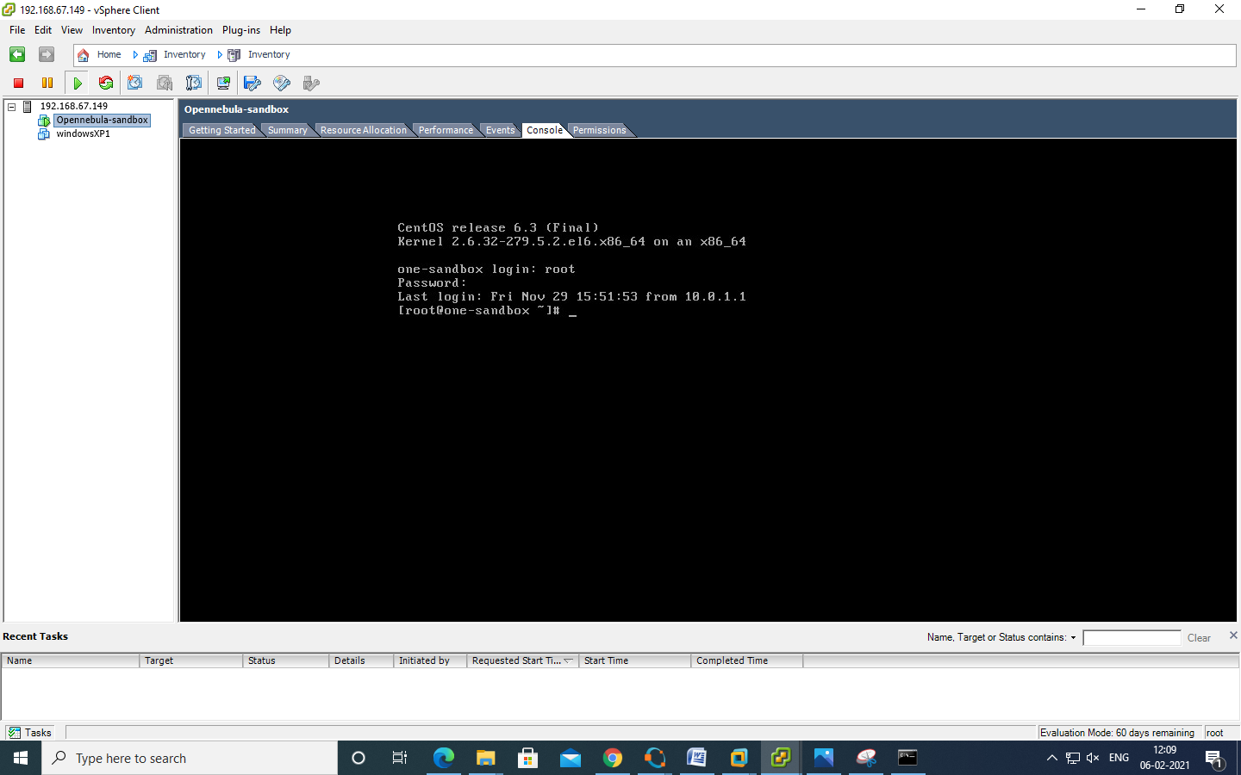

Type ifconfig eth0 command to check ip address of linux centos machine

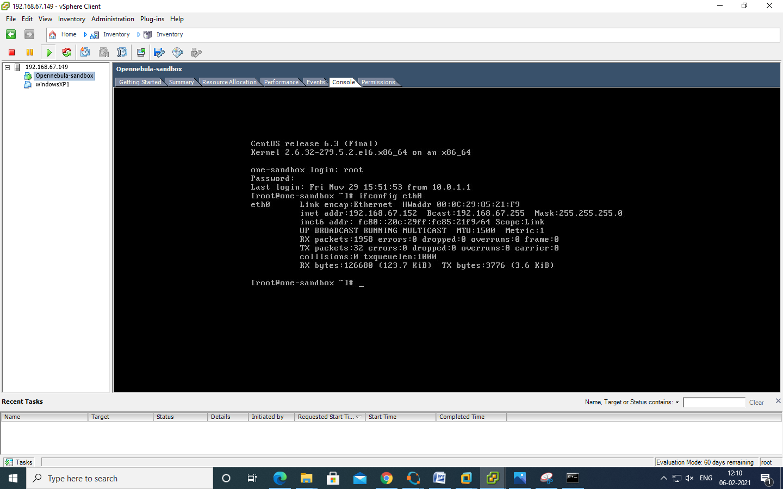

Since ip address of openebulla is 192.168.17.129

Now try to ping 192.168.67.152 openebulla on host OS

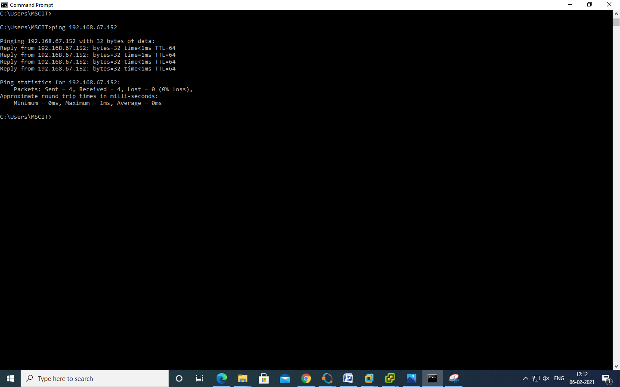

Go to Browser copy the http path and paste it.

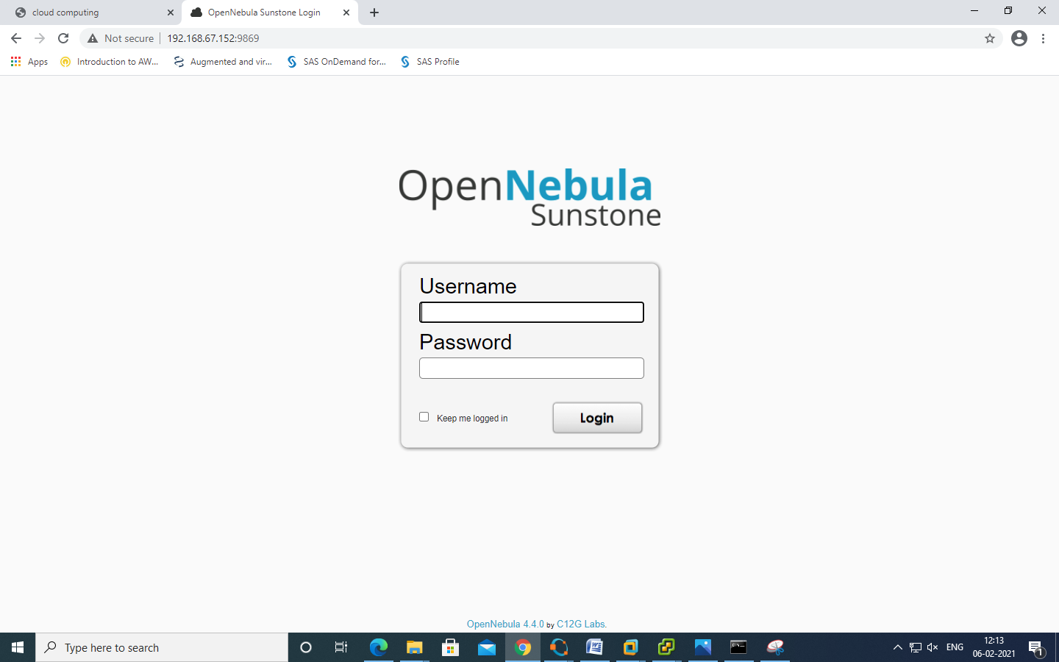

type username : oneadmin

password : Opennebula

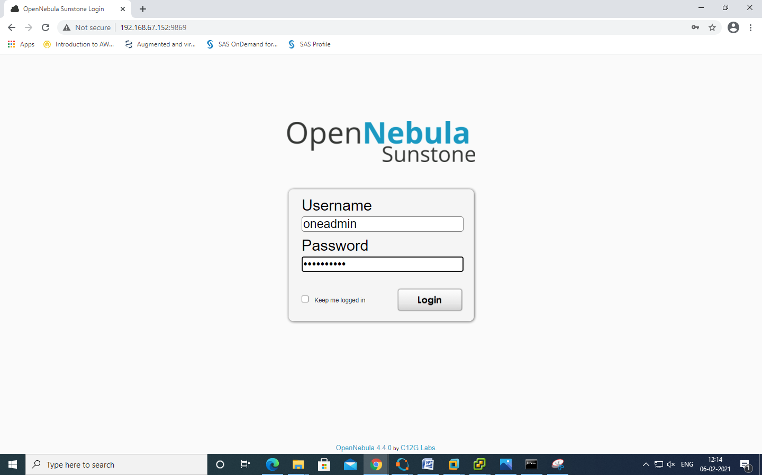

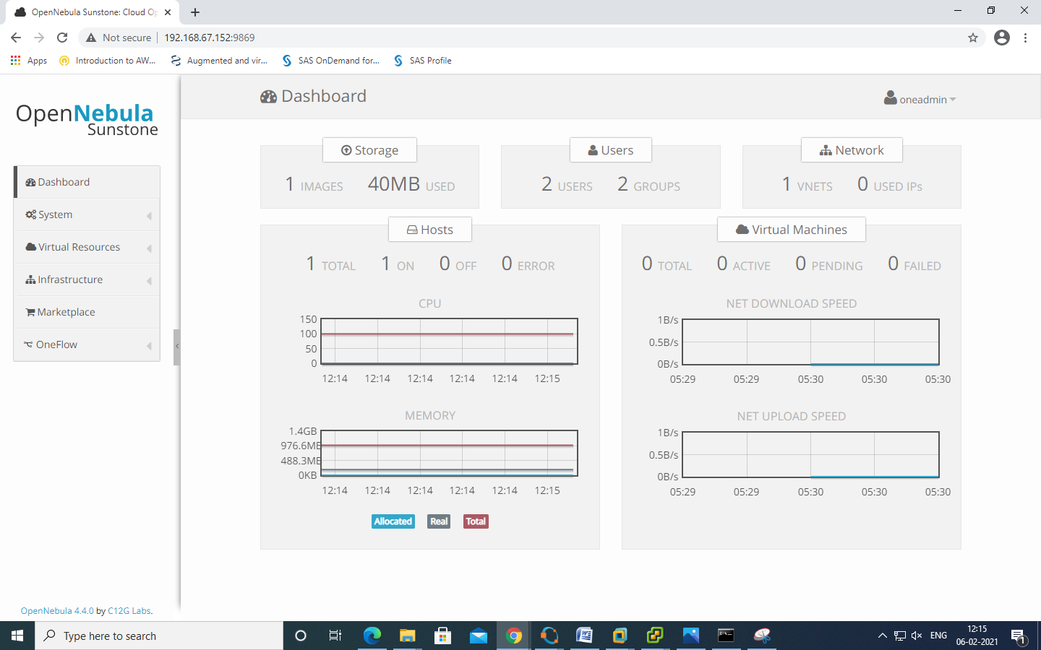

To create Datastore >> Click on "Create" >> Type name Divya and click on "create"

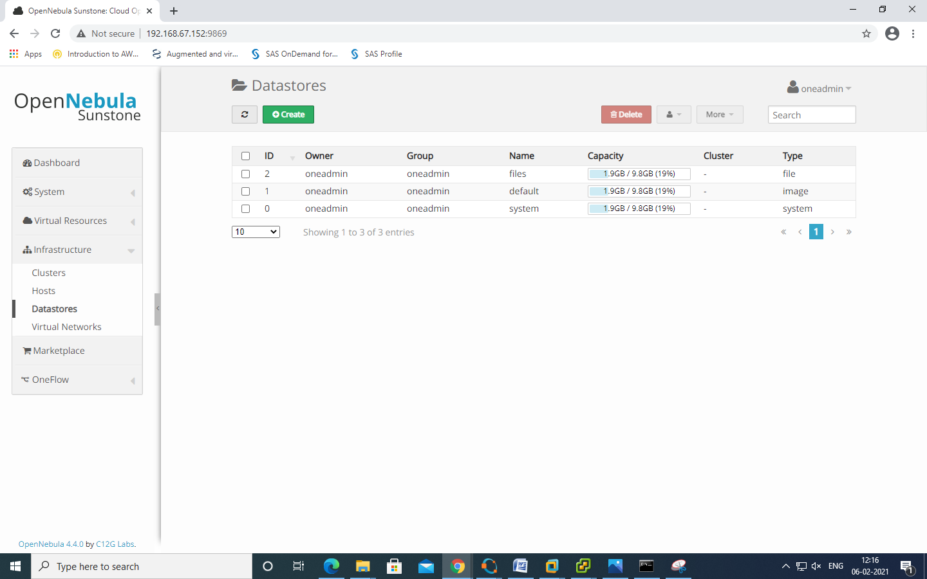

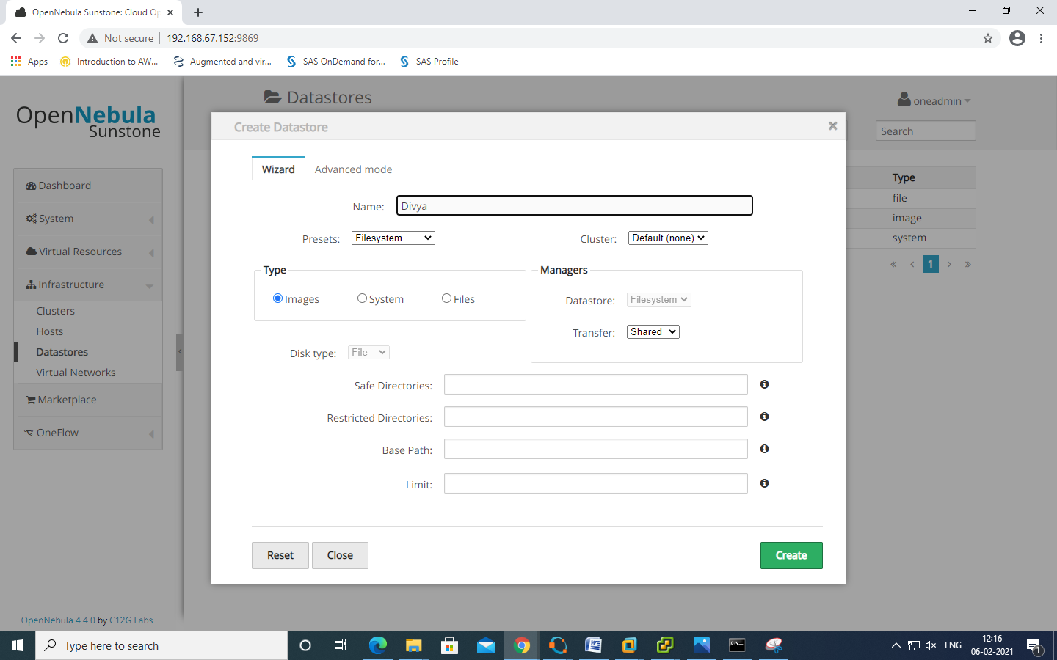

DATASTORE is created

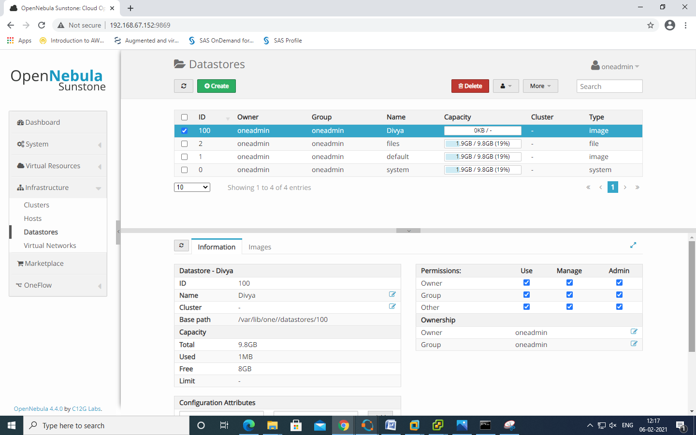

Now we will create "Virtual Network"

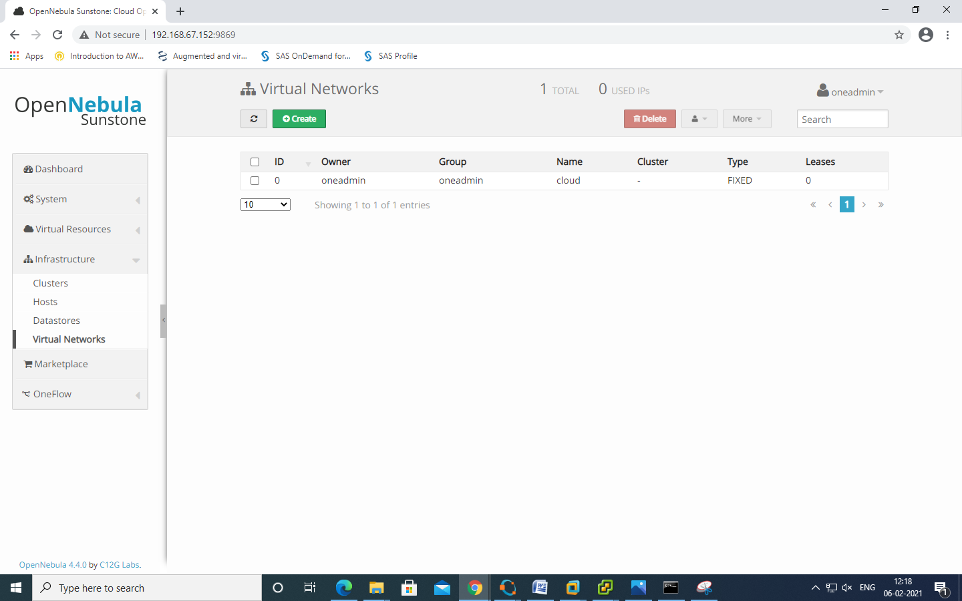

Click on "Create" >> Provide name as "Divya_Network"

Click on Fixed Network >> Give IP address in range "192.168.1.100" to "192.168.1.106"

and also provide Bridge name : "br0"

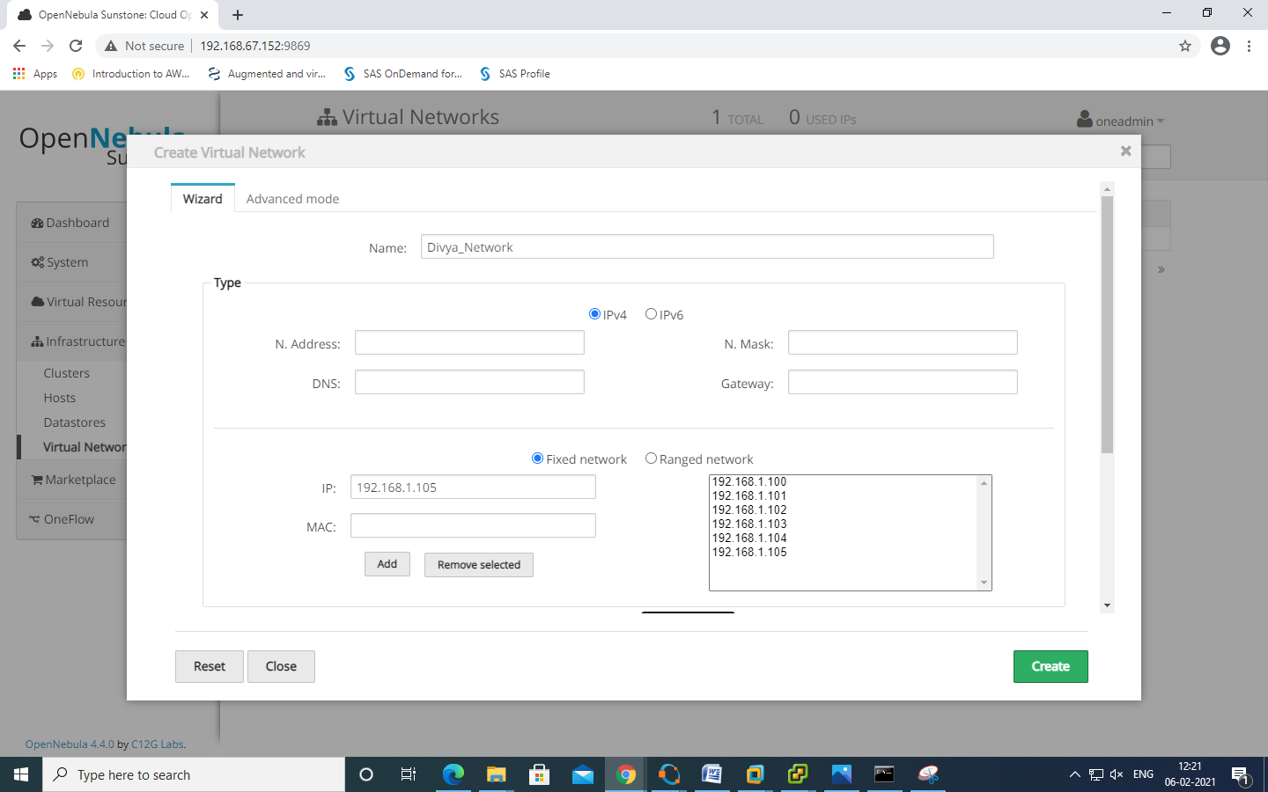

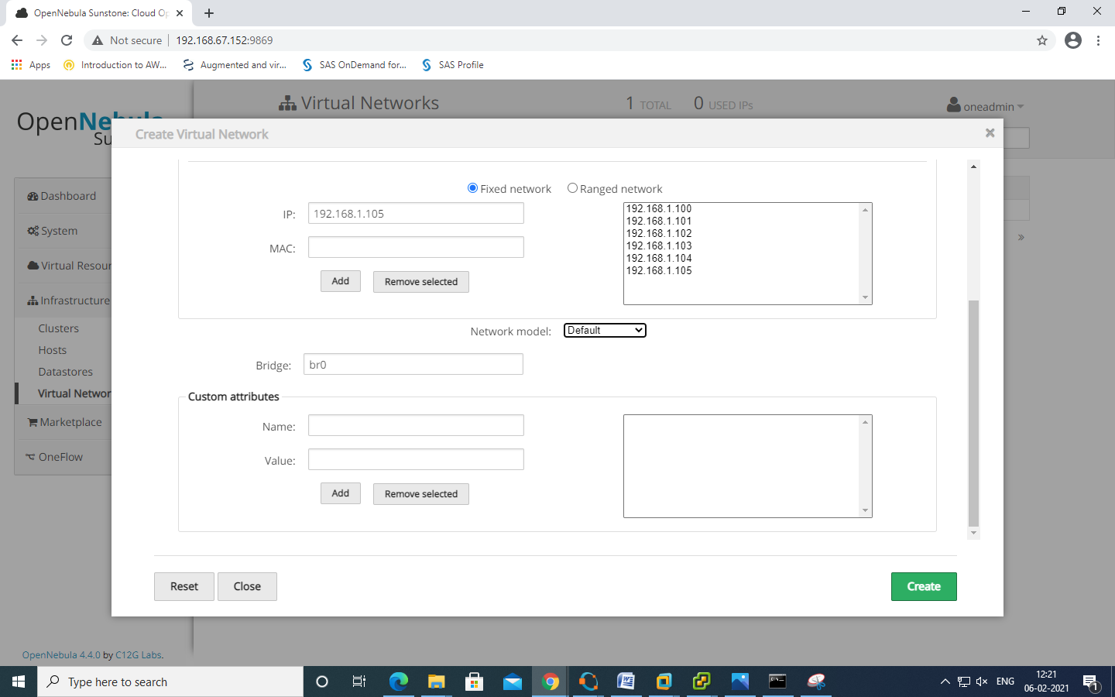

Create new user >> Name :root >> Password : opnenebula

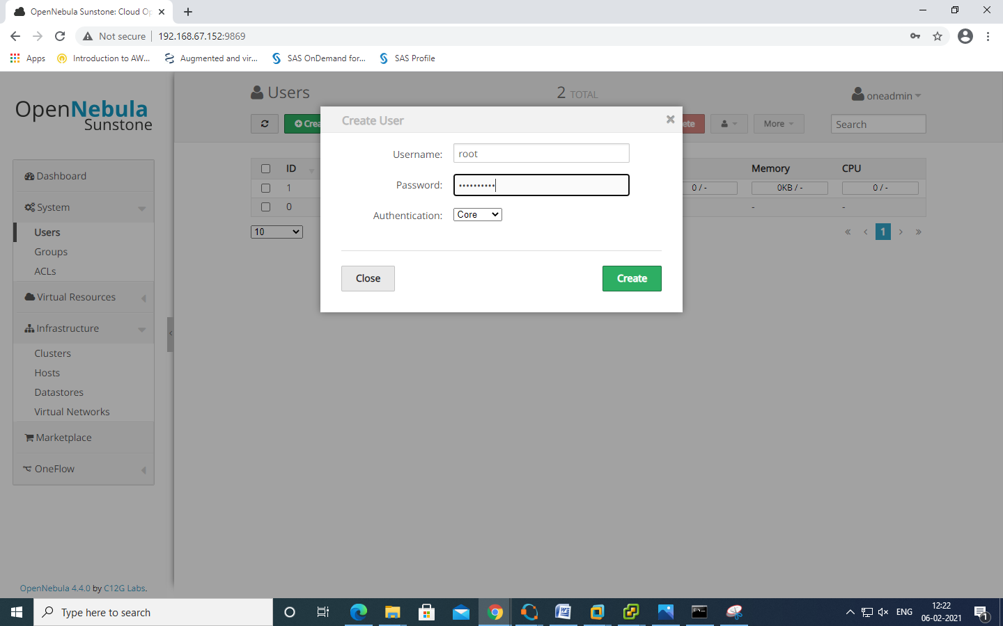

Now login again as >> Username : root >> Password : Opennebula

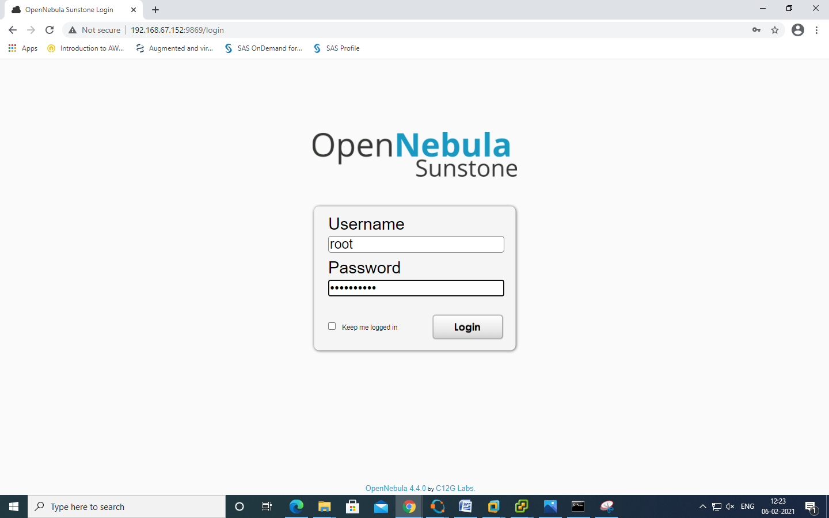

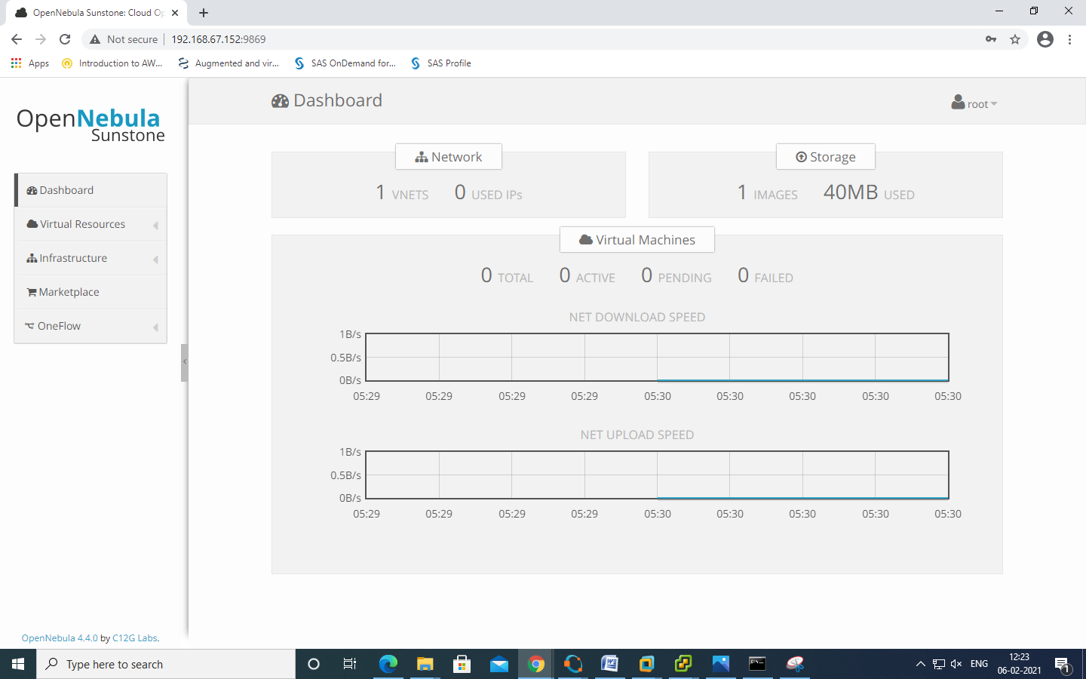

click on "Virtual Resources" and images

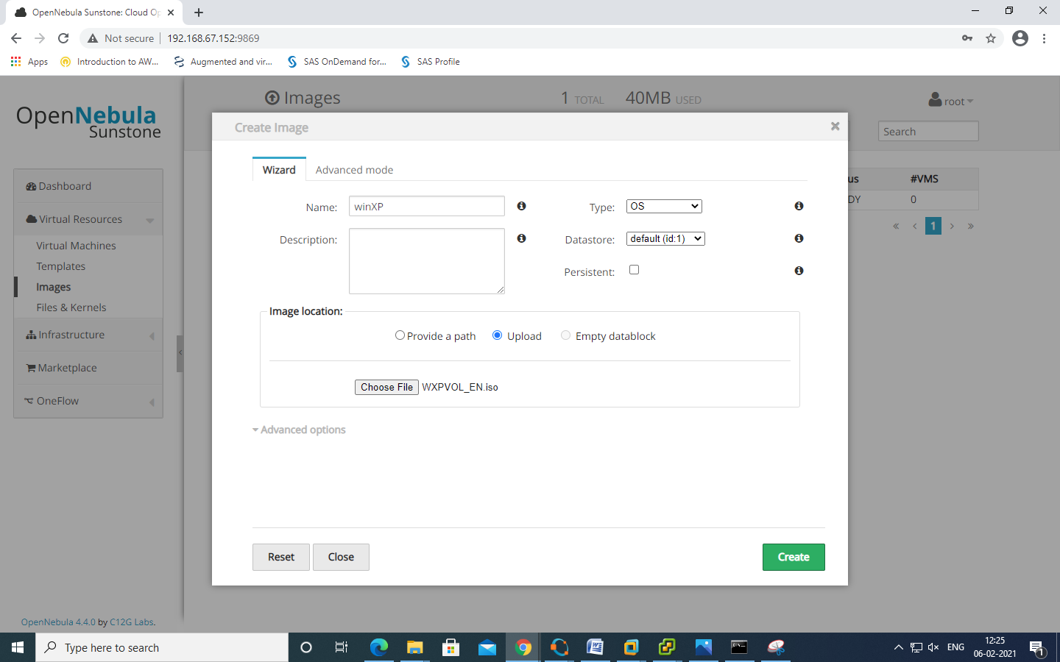

now register blank img >> ISO FILE

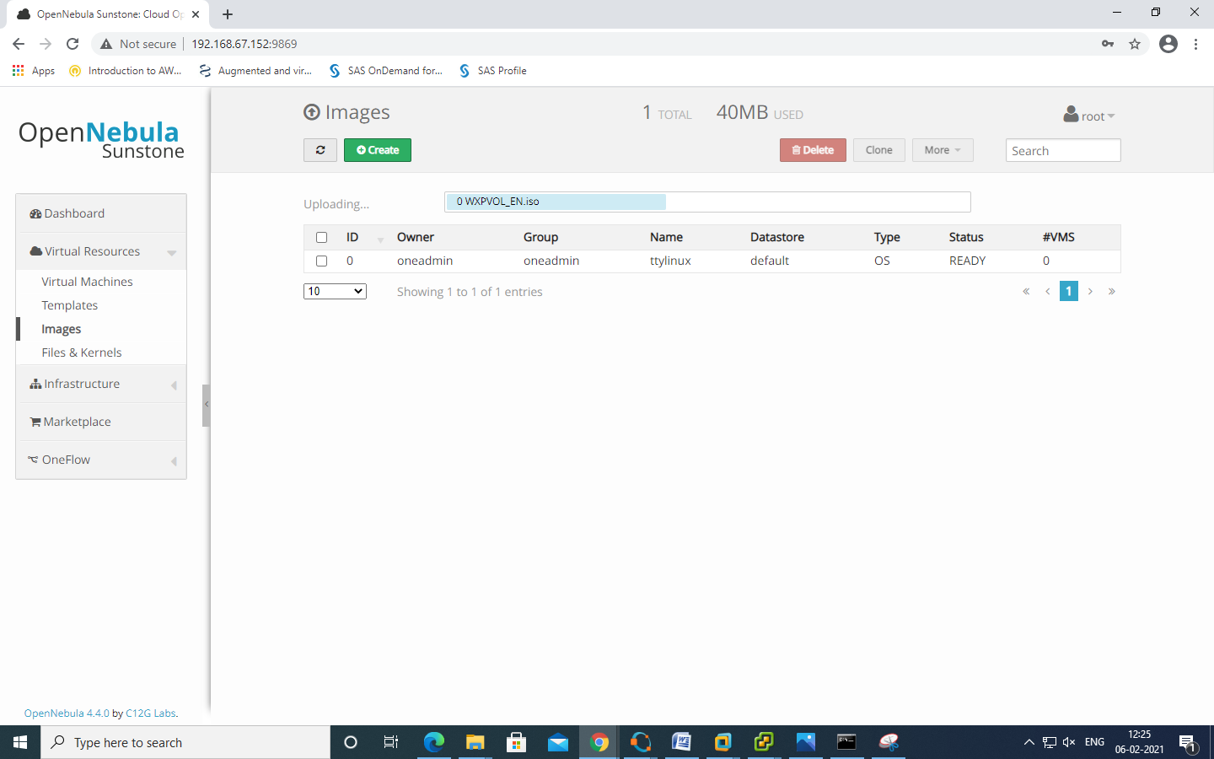

Click on template >> Click on storage

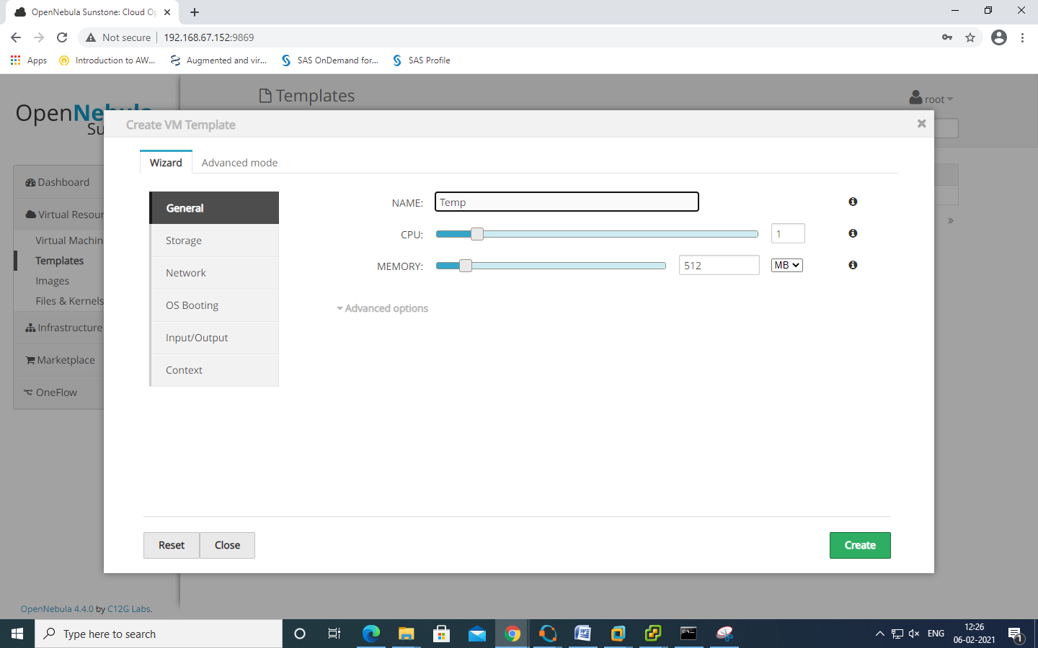

Click on add another disk

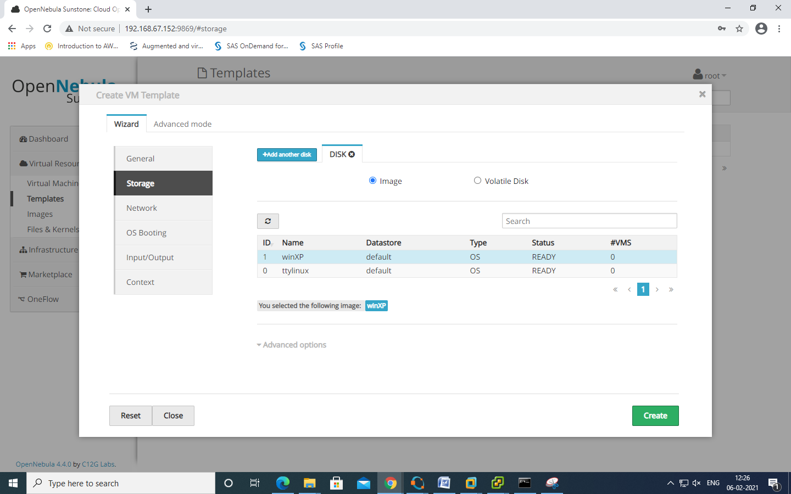

Click on "Network" and select network we have created

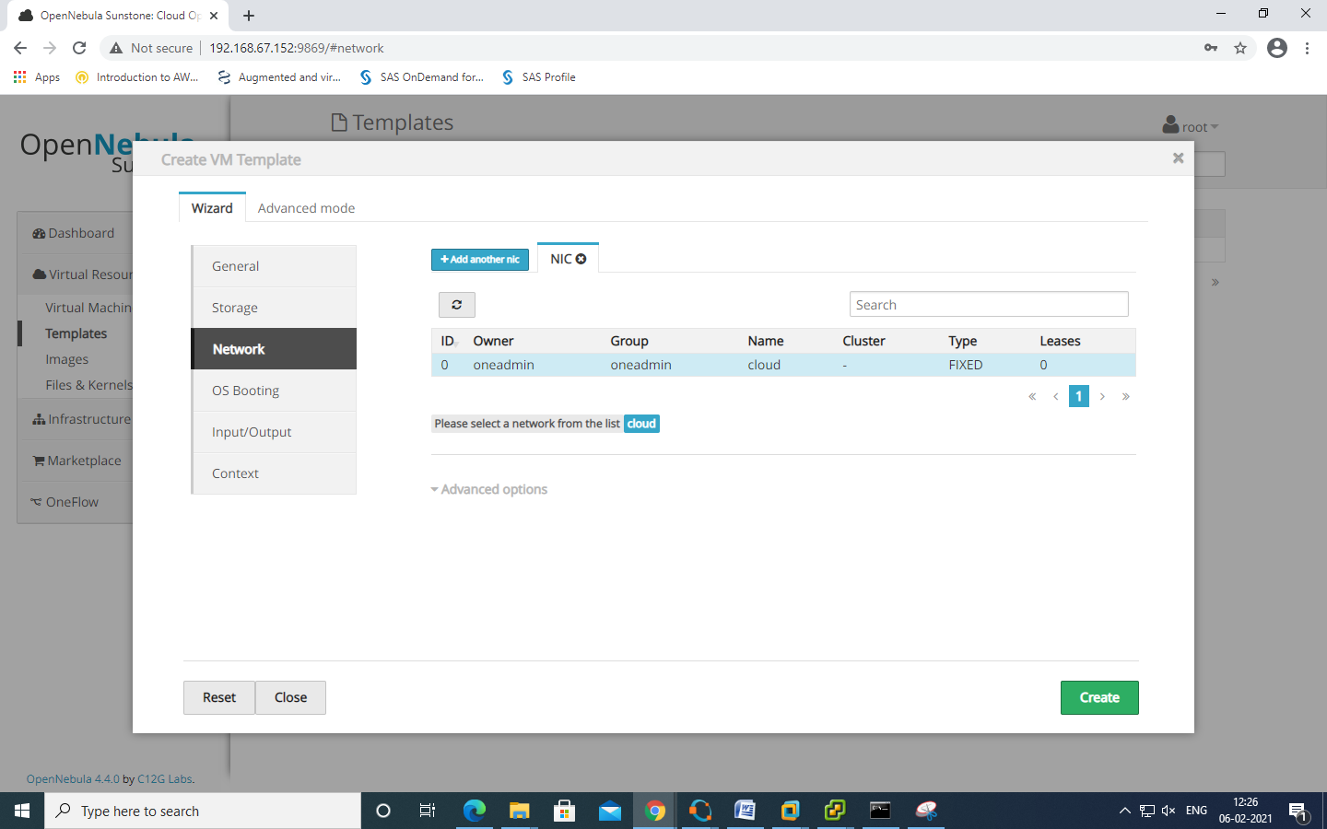

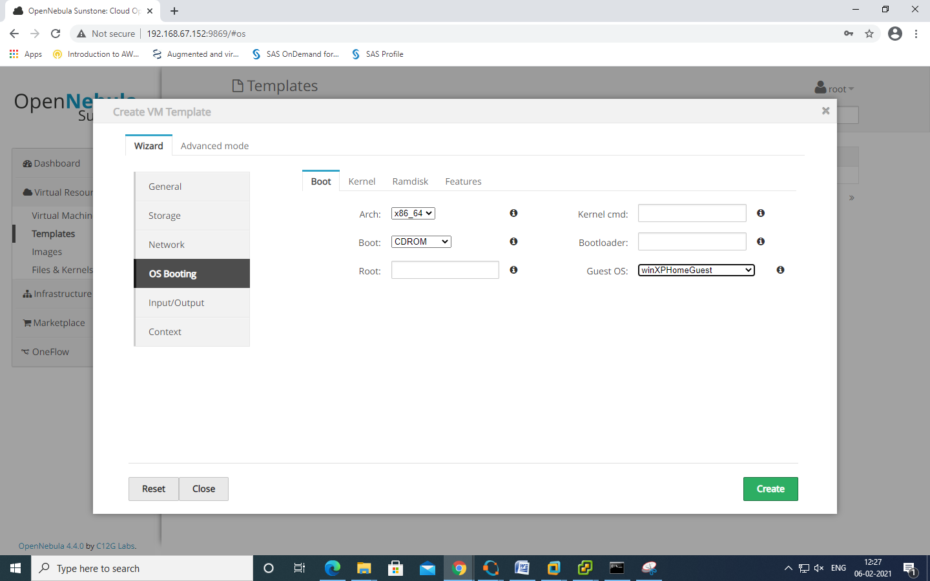

Click on "INPUT/OUTPUT " SELECT "VNC"

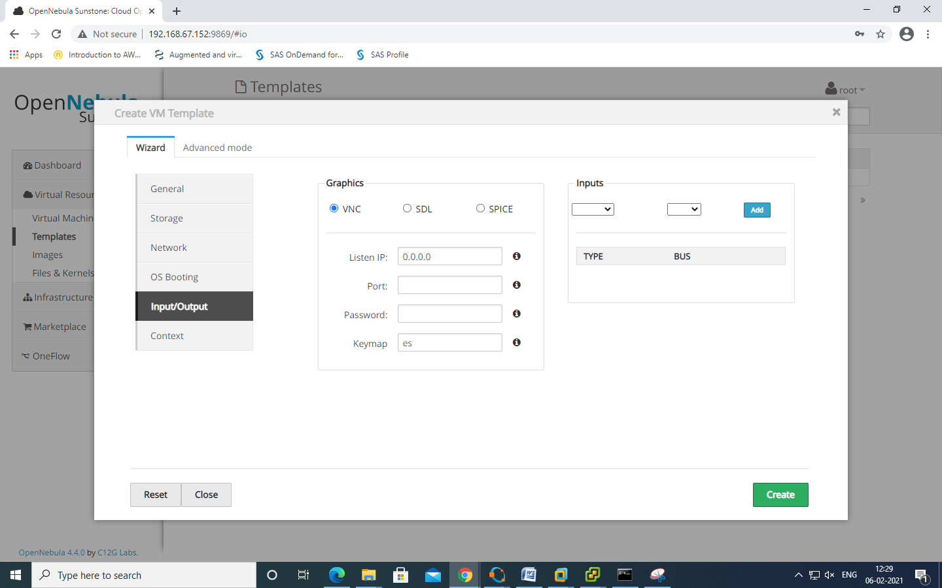

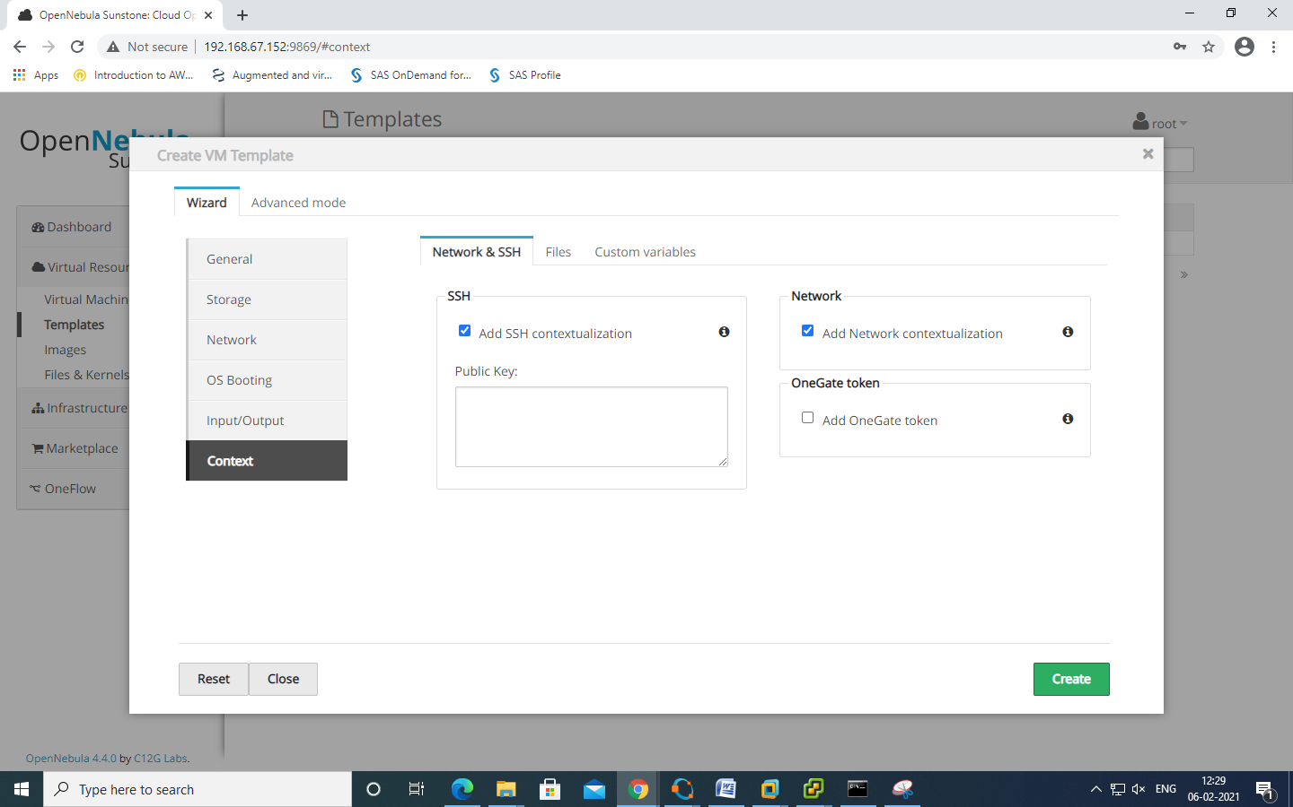

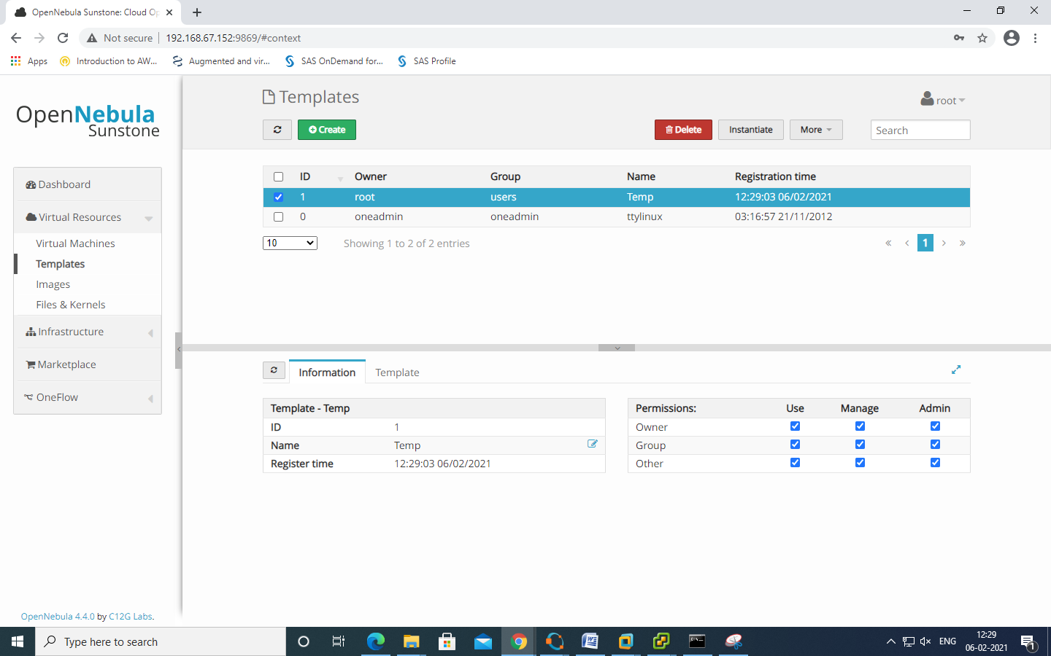

NOW click on INSTANTIATE

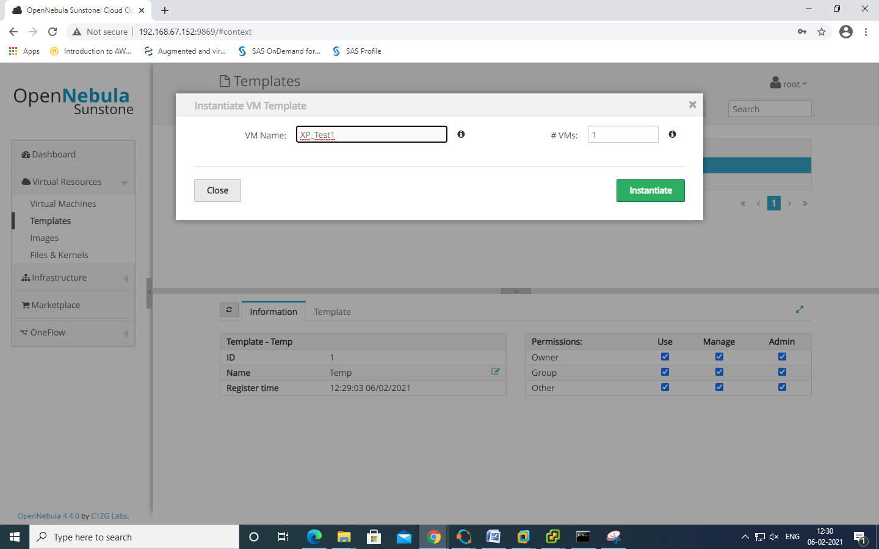

CLICK ON "VIRTUAL MACHINES" >> CLICK ON REFRESH ICON

